Lesson 210 – Point-in-Plane Joints

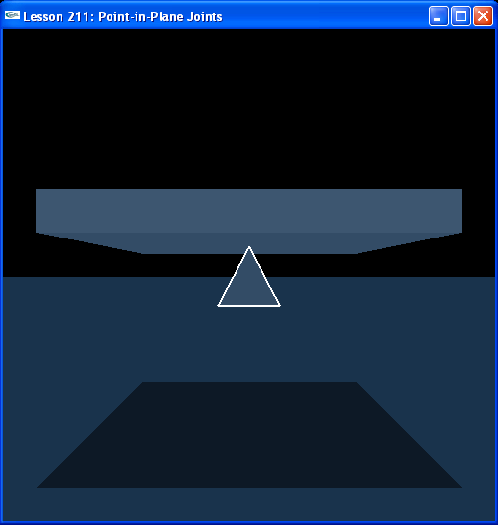

Introduction
우리가 배울 마지막 joint는 point-in-plane joint 이다. 이 joint는 actor들이 두축을 따라 병진이동하고 서로에 대해서 모든축에 대해서 회전하도록 한다. Point-in-plane joint의 예는 평면을 따라 움직이고 평면에 부착되어 있는 동안 어떤 축에대해서 자유롭게 회전하는 물체인 냉장고 자석이 될수있다.
The last joint we will learn about is the point-in-plane joint. This joint allows its actors to rotate about all axes with respect to each other and translate along two axes. An example of a point-in-plane joint would be a refrigerator magnet, something that moves along a planar surface and is free to rotate around any axis while attached to the plane.

Point-in-Plane Joints
지난 lesson에서 down wedge 대신 우리는 pyramid 에 부착시킬 kinematic box를 만든다.
Instead of the down wedge from the last lesson, we make a kinematic box that we attach the pyramid to.

// Actor globals
NxActor* box = NULL;
NxActor* pyramid = NULL;

// Joint globals
NxPointInPlaneJoint* pipJoint = NULL;
…
void InitNx()
{
…
box = CreateBox(NxVec3(0,6,0), NxVec3(5,0.5,5), 10);
box->raiseBodyFlag(NX_BF_KINEMATIC);
pyramid = CreatePyramid(NxVec3(0,4,0), NxVec3(1,1,1), 10);
pyramid->setLinearDamping(0.5);
pyramid->setAngularDamping(0.5);

NxVec3 globalAnchor = NxVec3(0,6,0);
NxVec3 globalAxis = NxVec3(0,1,0);
pipJoint = CreatePointInPlaneJoint(box, pyramid, globalAnchor, globalAxis);
…
gSelectedActor = pyramid;
}

globalAnchor는 pyramid의 끝과 중앙에 있고 box 의 바닥면을 따라 움직인다.
The globalAnchor is at the tip of the pyramid and in the middle and along the bottom surface of the box.

NxPointInPlaneJoint* CreatePointInPlaneJoint(NxActor* a0, NxActor* a1, NxVec3 globalAnchor, NxVec3 globalAxis)
{
NxPointInPlaneJointDesc pipDesc;
pipDesc.actor[0] = a0;
pipDesc.actor[1] = a1;
pipDesc.setGlobalAnchor(globalAnchor);
pipDesc.setGlobalAxis(globalAxis);
pipDesc.jointFlags |= NX_JF_COLLISION_ENABLED;

NxJoint* joint = gScene->createJoint(pipDesc);

return joint->isPointInPlaneJoint();
}

우리가 pyramid와 box 사이에서 충돌이 가능하도록 함에 따라 InitNx()에서 limiting plane들을 생성한다.
We enable collision between the pyramid and the box, as before, and build the limiting planes in InitNx().

void InitNx()
{
…
NxJoint* jointPtr = &pipJoint->getJoint();
jointPtr->setLimitPoint(globalAnchor);
// Add left-right and up-down limiting planes
jointPtr->addLimitPlane(NxVec3(1,0,0), globalAnchor - 5*NxVec3(1,0,0));
jointPtr->addLimitPlane(NxVec3(-1,0,0), globalAnchor + 5*NxVec3(1,0,0));
jointPtr->addLimitPlane(NxVec3(0,0,1), globalAnchor - 5*NxVec3(0,0,1));
jointPtr->addLimitPlane(NxVec3(0,0,-1), globalAnchor + 5*NxVec3(0,0,1));
…
}

Limiting plane들은 box의 모서리를 따라 평행을 이루고 ground에 수직을 이룬다. 그것들은 box의 어떤 쪽으로든지 움직여 떨어지려고 할 때 pyramid의 끝을 붙잡는다.
The limiting planes are flush with the edges of the box and perpendicular to the ground. They catch the pyramid by the tip if it tries to move off any side of the box.

Conclusion
이것으로 Point-in-plane joint training program을 종결한다. 여러분은 이제 SDK에서 joint의 모든 주요 type들을 생성하고 spring들과 motor들 부착하는 방법을 알고 있을 뿐만 아니라 limit value들과 limit plane들의 형태로 limit를 생성하는 법을 알고 있다. Joint들은 중급과정들의 심장부이다. 그것들은 Novodex SDK에서 rigid body들 사이를 연결하는 첫번째 방법이다.
This concludes the point-in-plane joint training program. You now know how to build all the major types of joint in the SDK, attach springs and motors to them as well as limits in the form of limit values and limit planes. Joints are the heart of the intermediate lessons, they are the primary method to make connections between rigid bodies in the Novodex SDK.

Related Classes, Functions, and Parameters
NxPointInPlaneJointDesc
NxPointInPlaneJoint

NxJoint
setLimitPoint()
addLimitPlane()
isPointInPlaneJoint()

NxJointFlag
NX_JOINT_COLLISION_ENABLED

